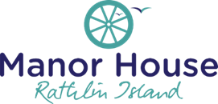
Dessert Menu

Baileys Crème Brûlée £6
Panna Cotta £6
Tiramisu £6
Café Affogato £6
Cheeseboard £
Sorbet £3.50
Ice Cream £3.50

Irish Coffee £6
Calypso Coffee £6
Seville Coffee £6

